Ryan Smith

CIS 320

Assignment 3

3/20/2017

**Use Cases**

**Use Case Name:** Making Online Donations             **ID:** 05       **Importance Level:** High

**Primary Actor:** Donors                                              **Use Case Type:** Essential

**Stakeholders and Interests**:

**Donor** – Wants to contribute to the KYHBPA and support their mission

**KYHBPA** – Wants to accept contributions to continue providing their services

**Brief Description:** This use case describes how donors can make an online donation through the KYHBPA website.

**Trigger:** Donor visits website and makes a donation

**Type:** External

**Relationships**:

**Association:** Donor, KYHBPA

**Include**:

**Extend:**

**Generalization:**

**Main Flow of Events:**

·         Donor access KYHBPA website

·         Donor navigates to “Donation” Page

·         Donor types donation amount into textbox

·         Donor clicks “Donate” button

·         Donor makes payment through online payment processing system

·         KYHBPA sends confirmation of donation

**SubFlows:**

S-1: Payment fails

1. The online payment does not succeed.
2. Online payment processor sends donor notice of failure.

**Use Case Name:** Accessing Partner Organizations             **ID:** 06       **Importance Level:** Low

**Primary Actor:** Members, Potential Members                                     **Use Case Type:** Overview

**Stakeholders and Interests:**

**Member** – Wants to gain information or utilize services of partners of the KYHBPA

**KYHBPA** – Wants to allow members to access the services of their partners

**Brief Description:** This use case describes how members can gain information and utilize the services of the KYHBPA’s partners

**Trigger:** Member visits website looking for information

**Type:** External

**Relationships**:

**Association:** Member, Potential Member

**Include**:

**Extend:**

**Generalization:**

**Main Flow of Events:**

·         Member accesses KYHBPA website

·         Member navigates to “Partners” page

·         Member clicks on the organization they are interested in

·         Member is redirected to that organization's website

·         Member obtains information and services from that website

**Use Case Name:** Accessing KYHBPA “About Us”            **ID:** 07       **Importance Level:** Medium

**Primary Actor:** Members, Potential Members                     **Use Case Type:** Overview

**Stakeholders and Interests:**

**Potential Member** – Wants to gain information about the KYHBPA

**Member –** Wants to gain information about the KYHBPA

**KYHBPA** – Wants to clearly give members and potential members an understanding of the organization and what their purpose is.

**Brief Description:** This use case describes how members and potential members can gain information about the KYHBPA

**Trigger:** Member or potential member visits website looking for information

**Type:** External

**Relationships**:

**Association:** Member, Potential Member

**Include**:

**Extend:**

**Generalization:**

**Main Flow of Events:**

·         Member accesses KYHBPA website

·         Member navigates to “About Us” page

·         Member looks for the information they desire

·         Member obtains information

·         Member clicks on “Contact Us” if they have a more detailed inquiry

**Use Case Name:** Polling Members            **ID:** 08       **Importance Level:** High

**Primary Actor:** Members, KYHBPA                      **Use Case Type:** Detail, Essential

**Stakeholders and Interests:**

**Member –** Wants to give input to the KYHBPA

**KYHBPA** – Wants to establish clarity on members’ opinions on important industry topics

**Brief Description:** This use case describes how the KYHBPA can poll its members.

**Trigger:** KYHBPA sends e-mail to members requesting a poll be done

**Type:** External

**Relationships**:

**Association:** Member, KYHBPA

**Include**:

**Extend:**

**Generalization:**

**Main Flow of Events:**

·         KYHBPA sends e-mail to member

·         Member opens e-mail

·         Member clicks link to poll

·         Member fills out poll

·         Member submits poll

·         KYHBPA reviews poll results

**System Requirements**

This document provides the functional and nonfunctional requirements for the requested system, cloud storage system and website to be created.  Requirements are organized in a hierarchy, and ranked by importance.

Functional Requirements

1. The cloud storage system will back up all important and prominent data to allow for recovery and business continuity.
2. The website will incorporate an online payment system, so the KYHBPA can receive donations online.
3. The website will push content and news to users to cut postage costs.
4. The website will be able to generate reports for users.
5. The website will have a form so members can register online.
6. The website will contact users when they need to be contacted, such as when a report request has been filled.
7. The website will give medicine change notices.
8. The website will include a dashboard about races (delays, track conditions, etc.).
9. The website will have an “about us” page that will describe their mission statement and the services the KYHBPA offers.
10. The website will have board member biography pages that contain photographs, short biographies, and contact information of key board members.
11. The website will have a calendar of events page.
12. The website will have a page with membership benefits and an outline of membership requirements.
13. The website will have a tool to poll members for decision making.
14. The website will have a page for meeting minutes between the horsemen committee members.
15. The website will have a page with links to partner organizations such as TAA, the KY Race Tracks, and contact information for each partner.
16. The website will be directly integrated with the KHBPA social media accounts.
17. The website will host a blog.
18. The website will have a message from the president page.
19. The website will be mobile compatible.
20. The website will have a racing/gambling education page.

Nonfunctional Requirements

1. Any code written for the website will use a CMS (WordPress).
2. Website content will be easily editable by employees of KHBPA.
3. The website will be progressive, youthful, and marketable (“shock and awe”)
4. The website will be visually distinct from similar organizations.

+**Use Case Diagram**

This diagram shows the relationships between the primary actors and the use cases. We can see that both potential members and members access the “About Us” and partner organizations use cases. While only donors access the Making Online Donations use case.

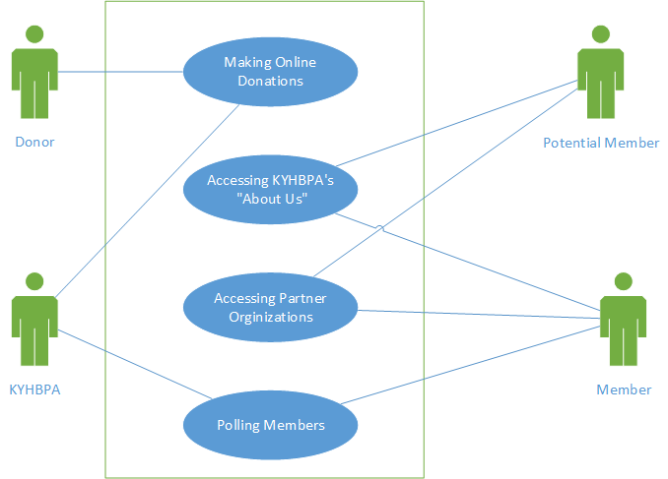

**Use Case Prototypes**

Making Online Donation Prototype

This prototype shows what a donation screen might look like. It has a textbox for a donor to enter their donation amount and a button that will take them to the online payment system.

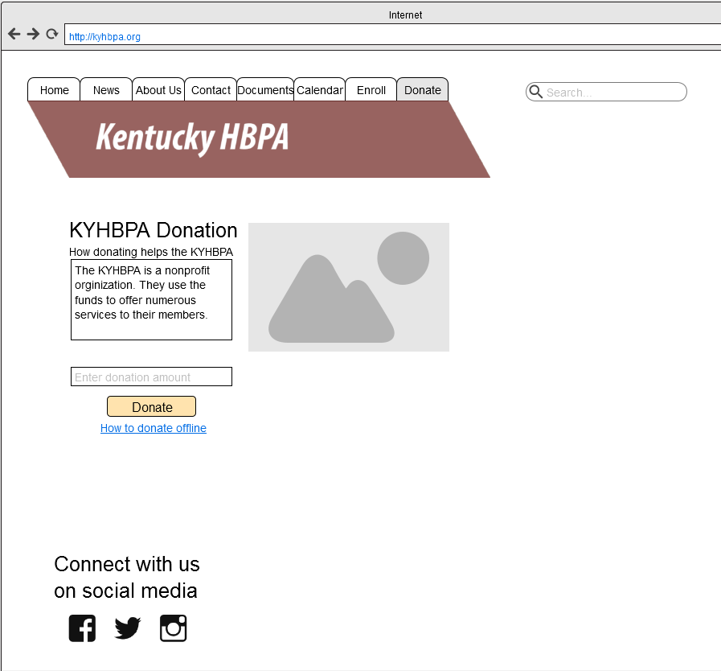

Accessing Partner Organizations Prototype

This prototype shows what a partners screen might look like. It has links and information about organizations similar to the KYHBPA.

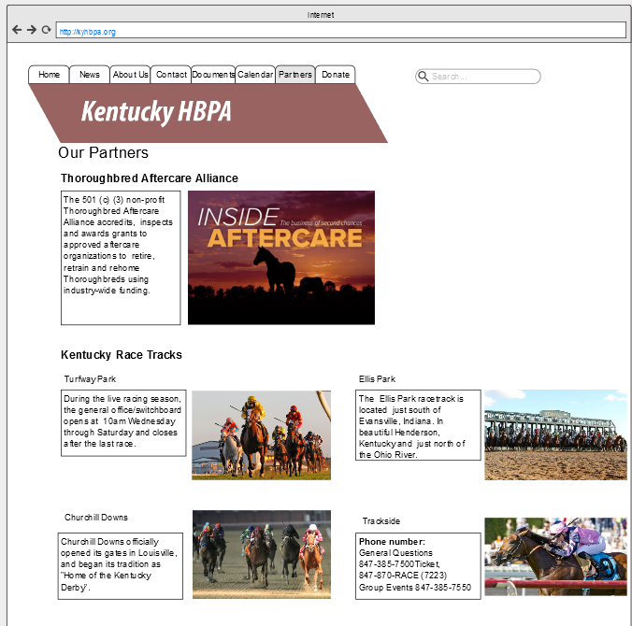

Accessing “About Us” Prototype

This prototype shows what an about us screen might look like. It has basic information about the KYHBPA and its purpose to inform members and potential members.

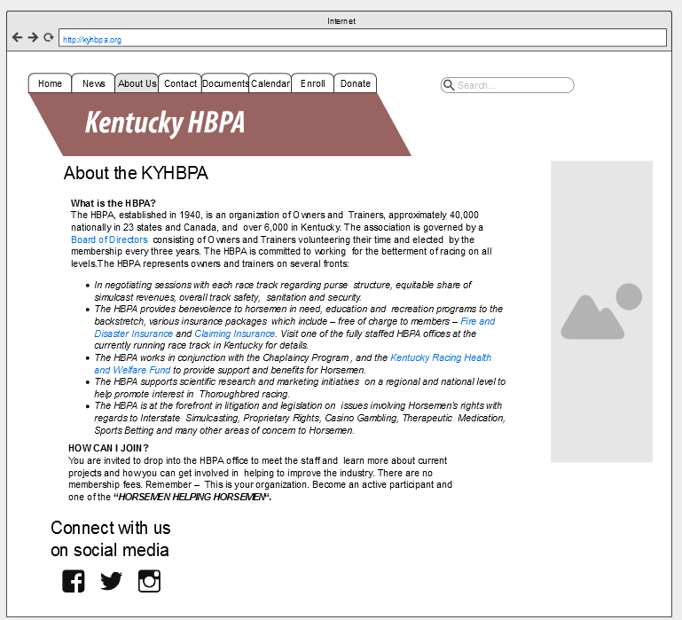

Polling Members Prototype

This screen shows what a polling page could look like. The questions could require drop down lists, text input, checkboxes, or radio buttons depending on the type of poll.

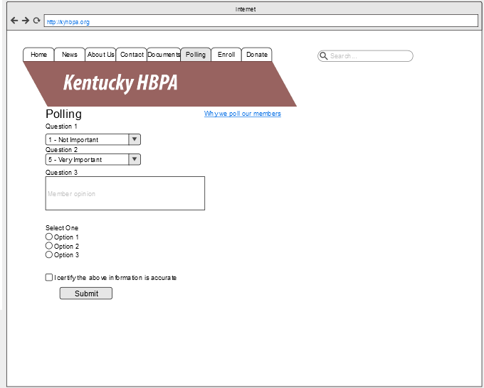

**Class Diagram**

This diagram shows the relationships between the classes required for our use cases. We can easily see that the KYHBPA has members and those members can respond to polls, access about us, and access partners.

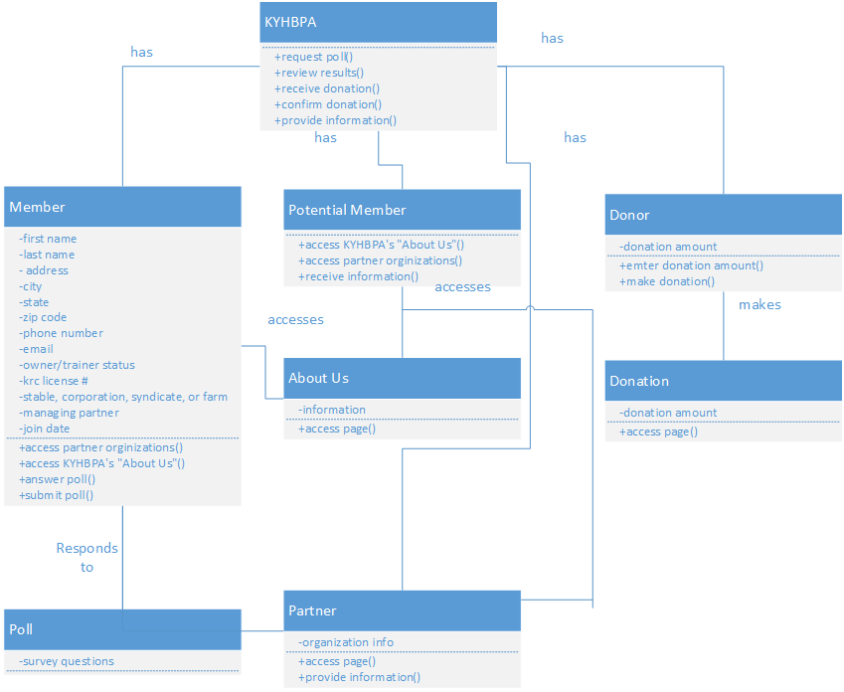

**Sequence Diagrams**

These diagrams show the objects and messages that are present in a use case.

Making Online Donation Sequence Diagram

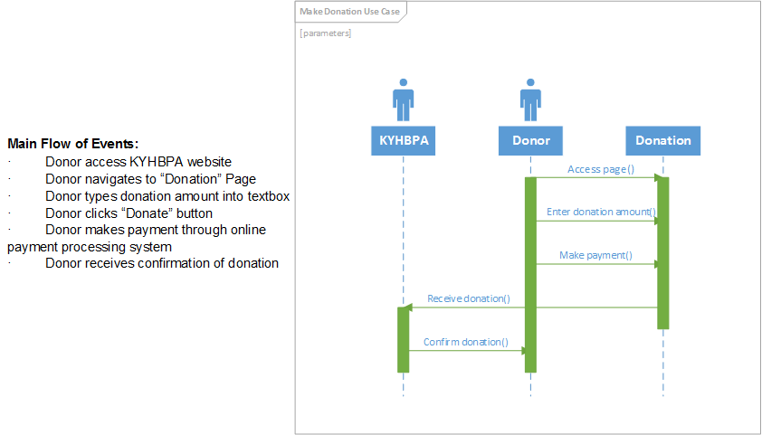

Accessing “About Us” Sequence Diagram

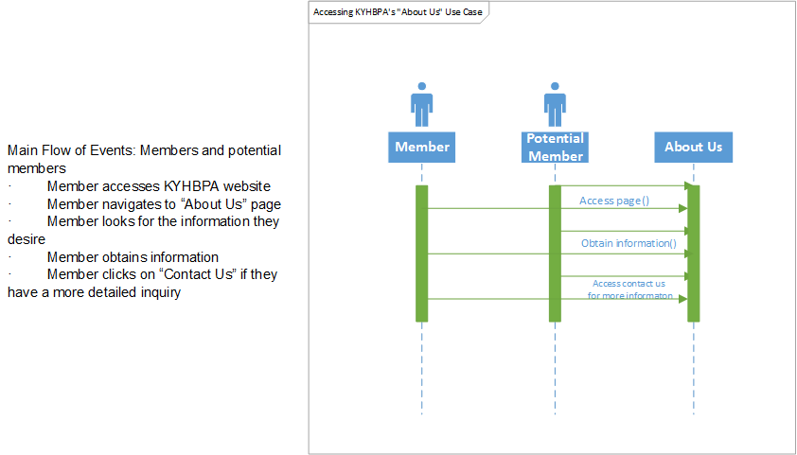

Accessing Partners Sequence Diagram

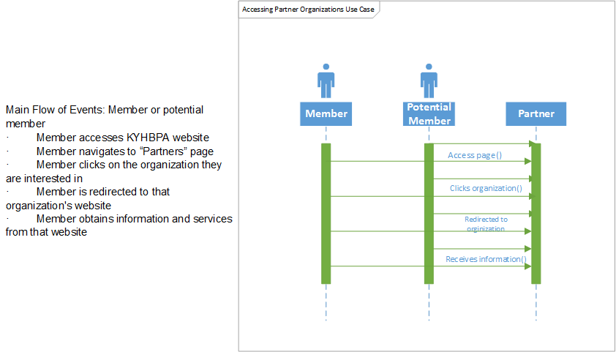

Polling Members Sequence Diagram

